Dead Space 2 guide Site Plan

Ryan Jimenez

WDD 130

Overview

Purpose
To give new players, or those interested, a brief window into the world of Dead Space, specifically Dead Space 2

Audience
Anyone who has interest in Dead Space 2 and its world.

Branding

Website Logo


Style Guide

Color Palette
Primary | Secondary | Accent 1 | Accent 2
#B3B3B3 | #C62222 | #010000 | #00D7D7

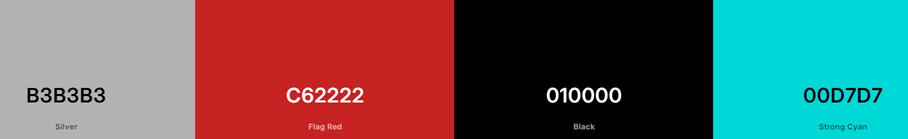

Typography

Heading Font: Dead Space Box art

Paragraph Font: Russel Square

Navigation
Home Page2 Page3

Content
dead space website-ds2

Wireframes

Home
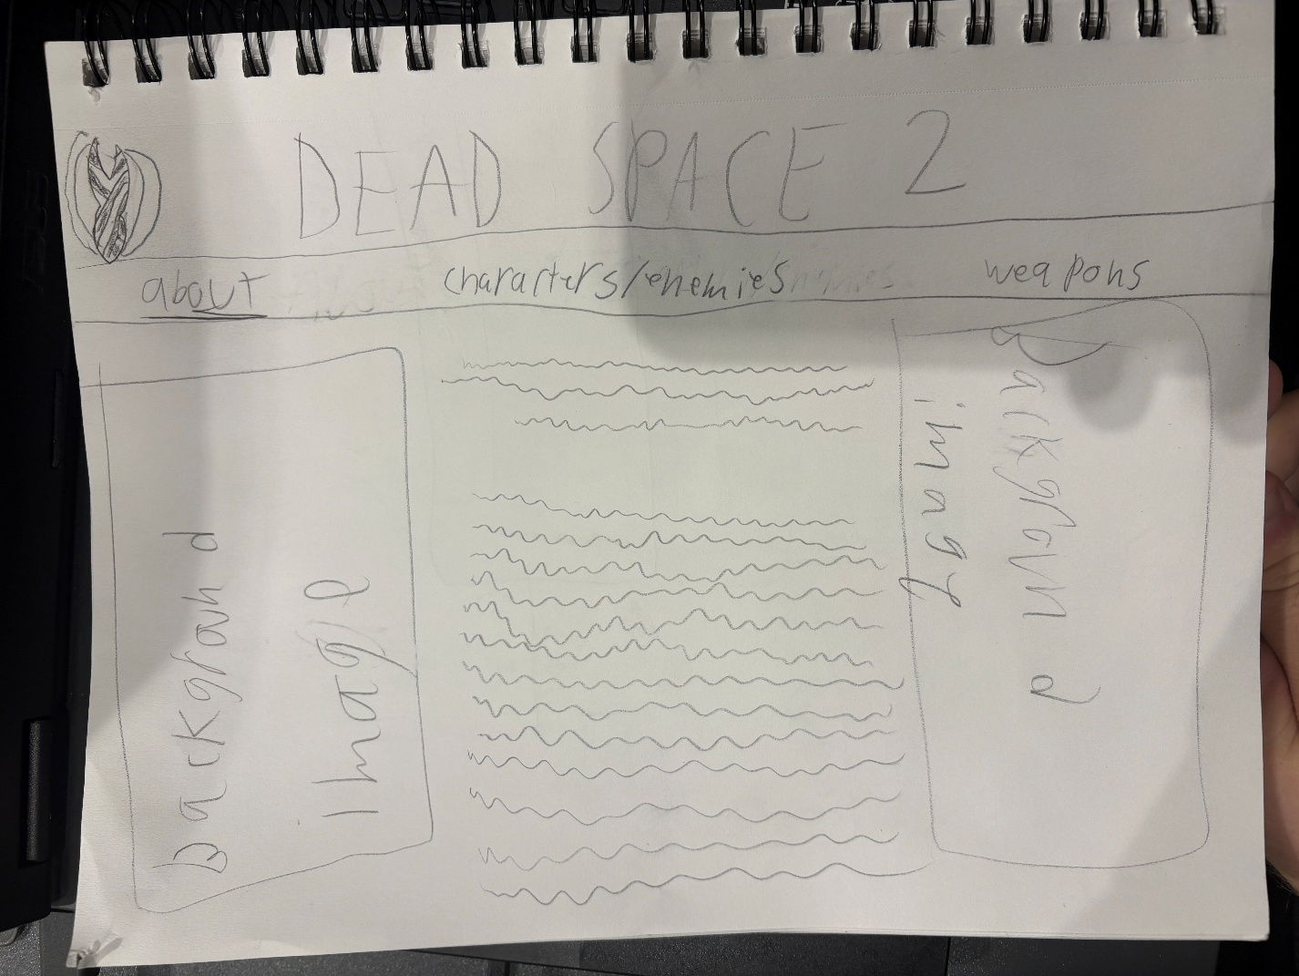

Other page
